Lab 1
CMPENG 331
Mohammad Abu Shariha

Code:
Src:
`timescale 1ns / 1ps
//////////////////////////////////////////////////////////////////////////////////
// Create Date: 09/07/2025
// Module(s) Name: dff3 and counter
// Project Name: 7 segment display
// Target Devices:
// Tool Versions:
// Description:
//
// Dependencies:
// Mohammad Abu Shariha
// Revision:
// Revision 0.01 - File Created
// Additional Comments:
//
//////////////////////////////////////////////////////////////////////////////////

// Module : D flip-flop
// Description : At the positive edge of the clock, set the current state based on the clear
// Input(s) : 3-bit Next State, Clear and Clock
// Output(s) : 3-bit Current State
module dff3(input [2:0] ns, input clrn, input clk, output reg [2:0] q);
always @ (posedge clk)
begin
if (clrn == 1) begin
q <= ns;
end
else begin
q <= 3'b000;
end
end
endmodule

// Module : Up/Down Counter
// Description : Combinational circuit that generates the next state and LED control signals based on input u
// Input(s) : 3-bit Current State, 1-bit u
// Output(s) : 3-bit Next State, 7 1-bit segments of the LED
module counter(input [2:0] q, input u, output reg [2:0] ns,
output reg a, output reg b, output reg c, output reg d, output reg e, output reg f, output reg g );
always @(*)
begin
if (u == 1) begin
if (q == 3'b101) begin
ns <= 3'b000;
end
else begin
ns <= q + 1;
end
end
else begin
if (q == 3'b000) begin
ns <= 3'b101;
end
else begin
ns <= q - 1;
end
end
case(q)
3'b000: begin
g=1'b1; f=1'b0; e=1'b0; d=1'b0; c=1'b0; b=1'b0; a=1'b0;
end
3'b001: begin
g=1'b1; f=1'b1; e=1'b1; d=1'b1; c=1'b0; b=1'b0; a=1'b1;
end
3'b010: begin
g=1'b0; f=1'b1; e=1'b0; d=1'b0; c=1'b1 ;b=1'b0; a=1'b0;
end
3'b011: begin
g=1'b0; f=1'b1; e=1'b1; d=1'b0; c=1'b0; b=1'b0; a=1'b0;
end
3'b100: begin
g=1'b0; f=1'b0; e=1'b1; d=1'b1; c=1'b0; b=1'b0; a=1'b1;
end
3'b101: begin
g=1'b0; f=1'b0; e=1'b1; d=1'b0; c=1'b0; b=1'b1; a=1'b0;
end
endcase
end
endmodule

testbench:
`timescale 1ns / 1ps
//////////////////////////////////////////////////////////////////////////////////
// Engineer: Mohammad Abu Shariha
//
// Create Date: 09/07/2025
// Design Name:
// Module Name: testbench
// Project Name: 7 segment display
// Target Devices:
// Tool Versions:
// Description:
//
// Dependencies:
//
// Revision:
// Revision 0.01 - File Created
// Additional Comments:
//
//////////////////////////////////////////////////////////////////////////////////

// Module : Testbench
// Description : Using the test sequence given generate the output of the 7 segment display by calling dff3 and counter modules
module testbench();
reg clrn_tb;
reg clk_tb;
reg u_tb;
wire [2:0] q_tb;
wire [2:0] ns_tb;
wire a,b,c,d,e,f,g;
dff3 dff3_tb(ns_tb, clrn_tb, clk_tb, q_tb);
counter counter_tb(q_tb, u_tb, ns_tb, a, b, c, d, e, f, g);
initial begin
clrn_tb = 0;
clk_tb = 1;
u_tb = 1;
#1 clrn_tb = 1;
#16 u_tb = 0;
end
always begin
#1;
clk_tb = ~clk_tb;
end
endmodule

Wave Form:
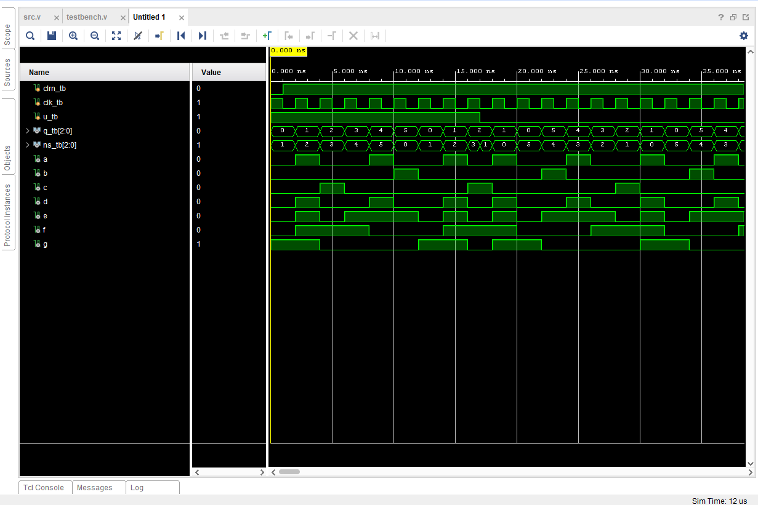

Schematic:
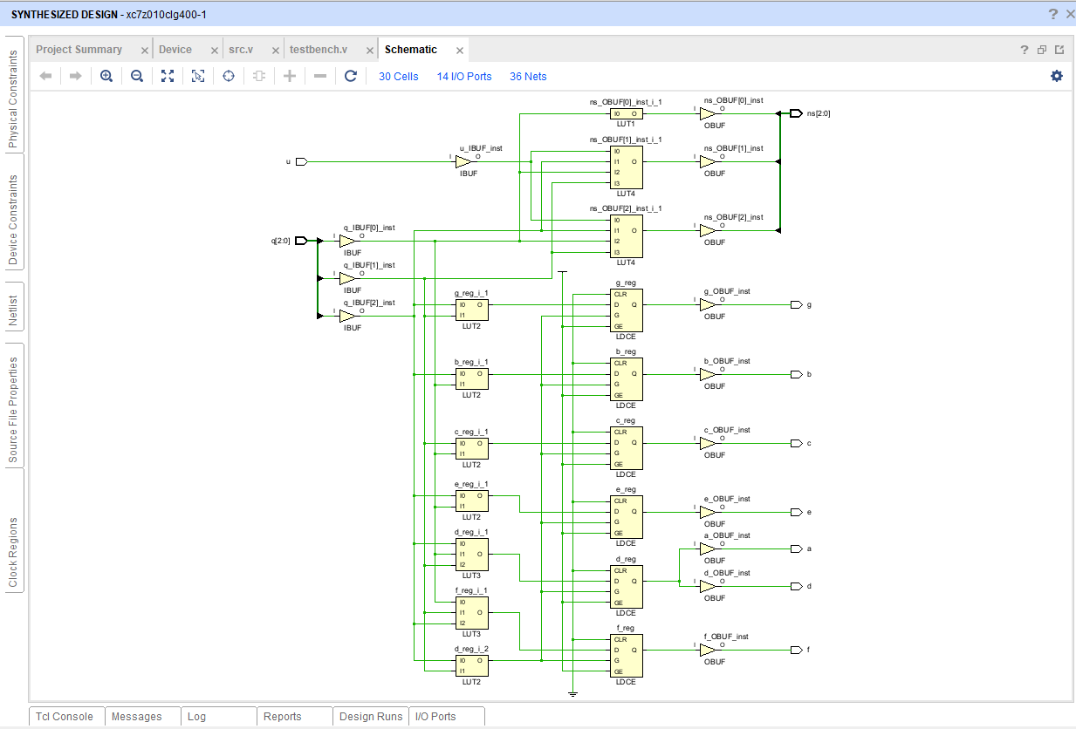

I/O Planning:
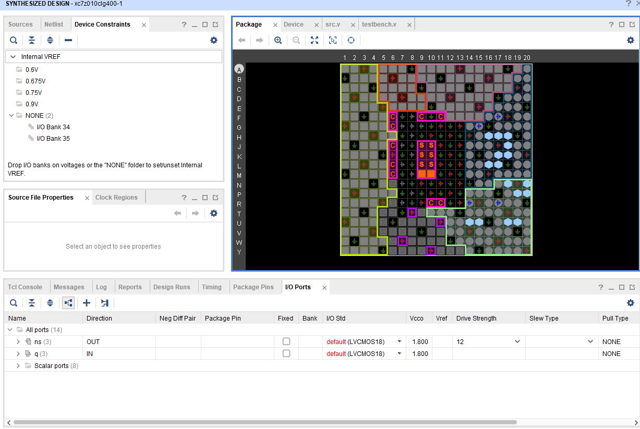

Floor Planning:
